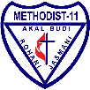 | SD SWASTA METHODIST-11 | Mata Pelajaran | : | B. Inggris |  | Nilai
 | SD SWASTA METHODIST-11 | Hari/Tgl | : | Kamis, 3 Desember 2026
 | Jl. Berlian Sari III No. 151 A | Kelas | : | VA SD
 | Soal Ujian Semester I T.P.2026/2027 | NIS / Nama | : | /

I. Pilihan Ganda CP 1 (100%)
1. The followings are nationalities.
a. Chinese and Japan
b. Canada and France
c. Singaporean and Korean
d. Australian and America
2. The followings are countries.
a. Australia and America
b. France and Chinese
c. Japan and Vietnamese
d. Spain and Canadian
3. The followings are subjects at school.
a. History and Assembly
b. Art and Science
c. Office and Geography
d. Volleyball and PE
4. The followings are stationeries.
a. Ruler and shoes c. Uniform and tie
b. Pencil sharpener and eraser d. Pencil and desk
5. The followings are animals.
a. Riding and giraffe c. Dolphin and crocodile
b. Butterfly and strawberry d. Tennis and banana
6. The followings are sports.
a. Baseball and I.t. c. Train and soccer
b. Volleyball and swimming d. Bus and bicycle
7. The followings are jobs.
a. Doctor and pilot
b. Shop assistant and hospital
c. Teacher and riding
d. TV station and reporter
8. The followings are places of work.
a. Hospital and driver.
b. TV station and airplane
c. Airport and school
d. Police station and interview
Read the text below and choose the correct answer for question No. 9 to 13
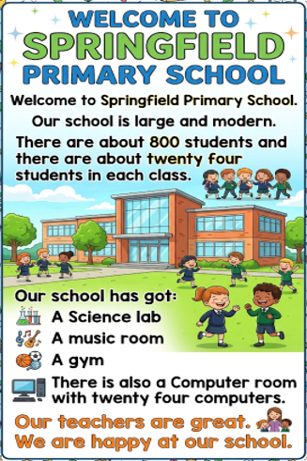
9. How many students are there in Springfield Primary School?
a. About 400 students c. About 800 students
b. About 600 students d. About 1,000 students
10. How many students are there in each class?
a. About 12 students c. About 24 students
b. About 20 students d. About 30 students
11. Which room is NOT mentioned in the text?
a. A Science lab c. A Gym
b. A Music room d. An Art room
12. How many computers are there in the Computer room?
a. 12 computers c. 24 computers
b. 20 computers d. 30 computers
13. How do the students feel about their school?
a. They are bored. c. They are worried.
b. They are happy. d. They are tired.
Read the article below then choose the correct answer for questions below it.
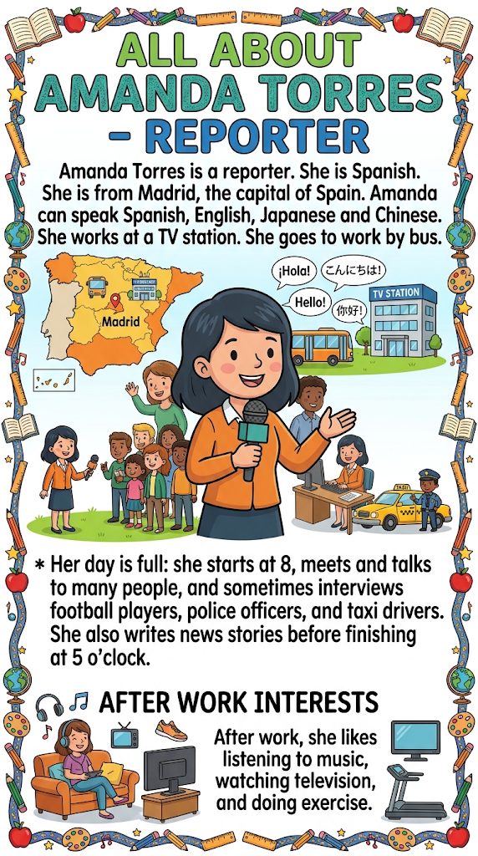
14. Where is Amanda Torres from?
a. Barcelona c. Tokyo
b. Madrid d. London
15. How many languages can Amanda speak?
a. Two c. Four
b. Three d. Five
16. How does Amanda go to work?
a. By car c. By taxi
b. By train d. By bus
17. Who does Amanda sometimes interview?
a. Teachers and doctors
b. Football players and police officers
c. Students and musicians
d. Scientists and engineers
18. What does Amanda like doing after work?
a. Reading books and cooking
b. Playing football and swimming
c. Listening to music, watching television, and exercising
d. Meeting friends and shopping
19. _______ are you studying?
~I am studying (science)
a. What time c. What subject
b. Where d. Who
20. ____ are the students?
~They are (in the classroom)
a. What time c. How old
b. How many d. Where
21. _____ apples are there in the basket?
There are (ten) apples in the basket.
a. How many c. Where
b. What time d. How old
22. ______ is Samantha?
She is (ten years old)
a. How old c. How
b. How many d. Who
23. _____ are you talking to?
I am talking to (Mr. Parker)
a. What c. How
b. Who d. What subject
24. _______ are the students studying now?
They are studying (history)
a. How old c. What subject
b. How many d. What colour
25. ______ are your shoes?
They are (black)
a. How old c. What subject
b. How many d. What colour
II. Isian CP 2 (100%)
Look at the images in the table then complete the sentences with the correct words.
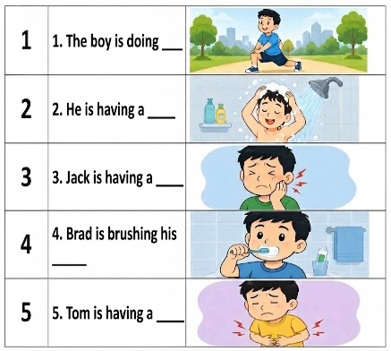
III. Isian CP 3 (100%)
Rewrite the words in order to make correct sentences.
1. reading / The children / are / in the library
= ....................................................................................
2. football / Some children / are playing / in the playground
= ....................................................................................
3. studying / Some students / maths / are.
= ....................................................................................
4. the computer room / There are / two students / in
= ....................................................................................
5. students / There are / twenty-five / in my class.
= ....................................................................................
IV. Essay CP 4 (100%)
Read the text below and answer the question.
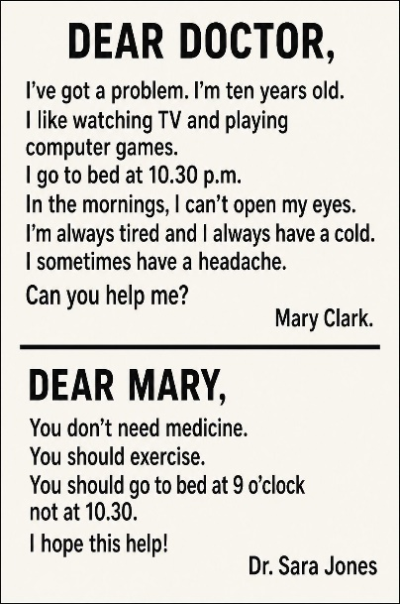
Questions:
1. How old is Mary Clark?
2. What does Mary like to do?
3. What time does Mary usually go to bed?
4. What does Dr. Sara Jones tell Mary to do?
5. What time should Mary go to bed?
Good Luck

